The Mustard Seed
Mustard Plant Craft
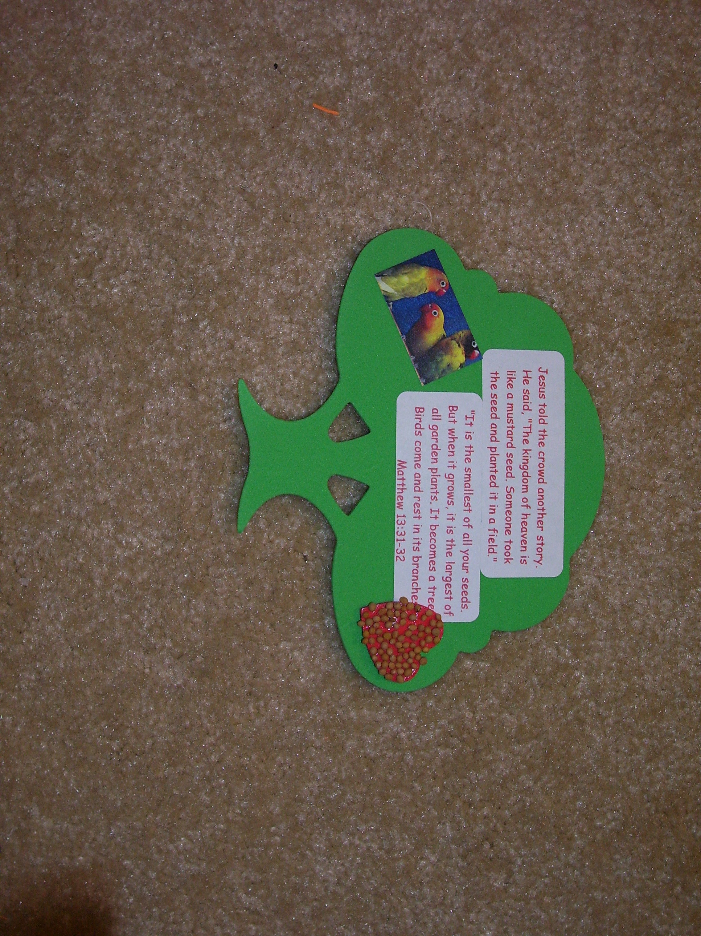

Directions:
- Choose a foam green tree shape
- Grab the Key Verse stickers and apply to front of tree
- Take a heart sticker, peal off the back and stick to the mustard seeds
- Apply a double faced white sticker to back of heart (removing backing)
- Remove backing and stick decorated heart to side of tree
- Add a bird sticker to front other side and a magnet on the back!

